# SIMULATION OF CONTROLLER

In order to provide gate signal to MOSFET or IGBT, we need to generate pulses. To do that, we need both controller and gate driver. As APPE, we decided to implement analog controller to our final design. However, initially the pulses are generated with a digital controller which is 555 Timer.

With the help of 555 Timer, we can generate pulses with desired period using pulse width modulation tecnique (PWM). The duty cycle of PWM signal is defined as the amount of time which is high or 1. It can be calculated as follows:

$$D=(\frac{T_{high}}{T})×100$$

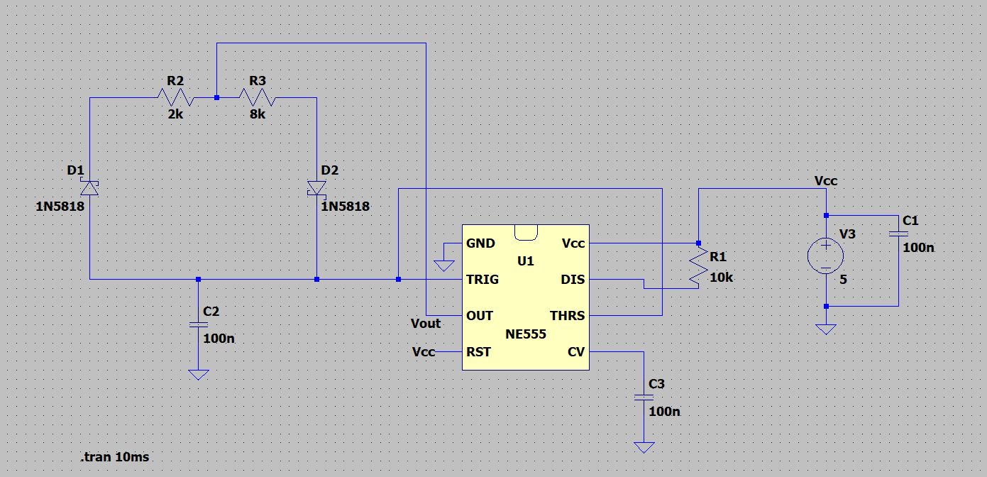 We succeed to generate pulses by using NE555 Timer in LT Spice, the circuit schmeatic is given in Figure 19.

Figure 9:The Circuit Schematic of 555 Timer PWM Generator

In this schematic, the circuit produces pulses with duty cycle about %50. Because R2 and R3 are fixed value. In the practical design, we are planning to use potentiometer in order to change resistance value so we can change the duty cycle as we want. The duty cycle can be calculated as follows:

$$D=((R_{2}+R_{3})/(R_{2}+2R_{3}))×100$$

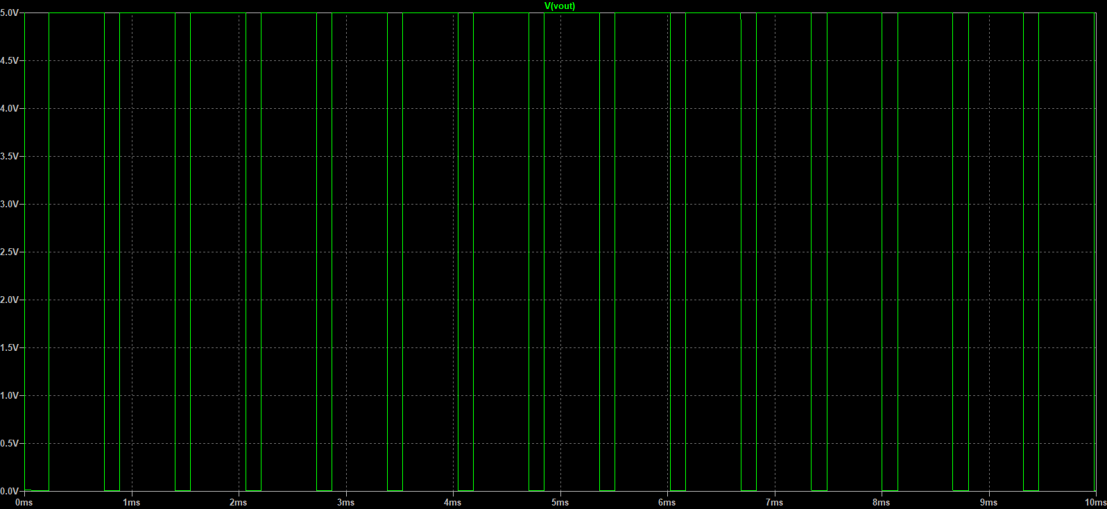The pulses that generated by this circuit is given in Figure 20.

Figure 0: The Pulse Generation with 555 Timer (D=0.5)

In addition to controller, the gate driver IC is required to drive MOSFET or IGBT. Therefore, as a gate driver will be simulated as possible in computer environment, also controller and gate driver will be tested in laboratory. For now, we decided to use TLP250 Optocouple as a gate driver.

However, the 555 Timer calculations are not enough now, the switching frequency should be also considered. In the next step, we will test LM555 Timer with potentiometer and observe which duty cycle can we produced. Also, since our future plan is implement analog controller, we will implement analog controller after we produced pulses as we want.